ANUGRAH NARAYAN COLLEGE, PATNA

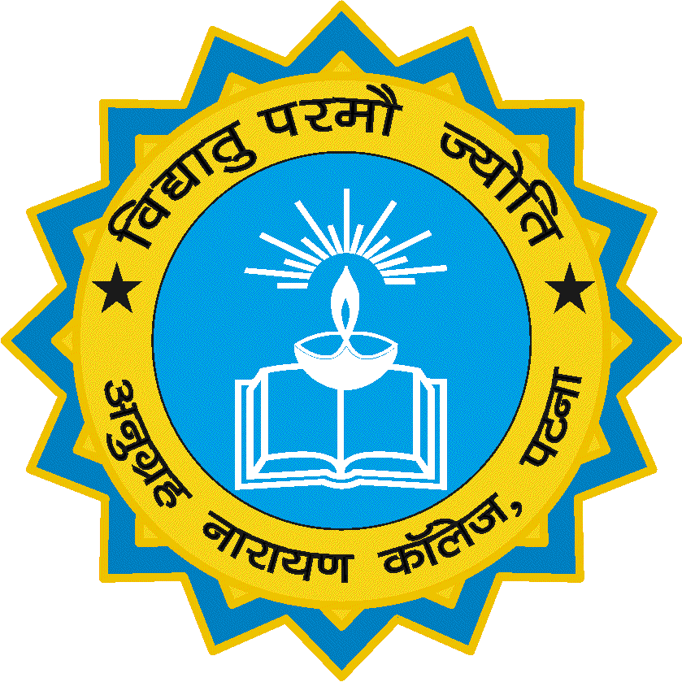

(A CONSTITUENT UNIT OF PATLIPUTRA UNIVERSITY, PATNA)
(NAAC REACCREDIATED GRADE – ‘A’ & CPE STATUS BY UGC)

A PROJECT REPORT ON

SYSTEM FOR LOAN MANAGEMENT

Submitted in partial fulfilment of the requirements for the award of the degree of Bachelor of Computer Applications (B.C.A.)

Department of Computer Applications (B.C.A.),
Anugrah Narayan College, Patna – 13

Guide: Submitted By:
Er. A.K. Singh, Roll No. Students Name
Department of MCA, 21 Abhishek Kumar
A.N. College, Patna – 13 64 Safiullah
70 Md. Azeem
98 Kumar Anmol
112 Abhishek Kumar Singh
Hon’s BCA Part – III (2018 – 21)


Submitted To
Patliputra University, Patna, Bihar

DECLARATION

This is to certify that the dissertation / project report entitled “System For Loan Management” done by me is an authentic work carried out for the partial fulfilment of the requirements for the award of the degree of Bachelor of Computer Applications (B.C.A) under the guidance of Er. A.K. Singh. The matter embodied in this project work has not been submitted earlier for award of any degree or diploma to the best of my knowledge and belief.
Signature of the student
(______________________)
Roll No.: 70
Course: B.C.A.
Session: 2018 - 21

CERTIFICATE OF ORIGINALITY

This is to certify that the project report entitled “System For Loan Management” submitted to Patliputra University, Patna in partial fulfilment of the requirement for the award of the degree of BACHELOR OF COMPUTER APPLICATIONS (B.C.A.) through the Department of Computer Applications (B.C.A.), Anugrah Narayan College, Patna, is original work carried out by Md. Azeem bearing college roll no. 70 of session 2018 – 21 under my guidance.
The matter embodied in this project is genuine work done by the student and has not been submitted whether to this University or to any other University / College / Institute / Department for the fulfilment of the requirement of any course of study.

………………………. ...…………………….
Signature of the Student: Signature of the Guide

Roll. No., Name, Name, Designation
Course and Session: and Address of the
Guide:

Md.Azeem Er. A.K. Singh
Roll no.- 70 Department of M.C.A
B.C.A Anugrah Narayan College
Session- 2018-2021 Patna-13

